**How to Configure an Odoo Service in Pycharm**

Steps:

1.First Open Odoo-18 Directory in Pycharm.  
2.Go to setting add python interpreter add local path: **/home/odoo/.virtualenvs/odoo-18e.**

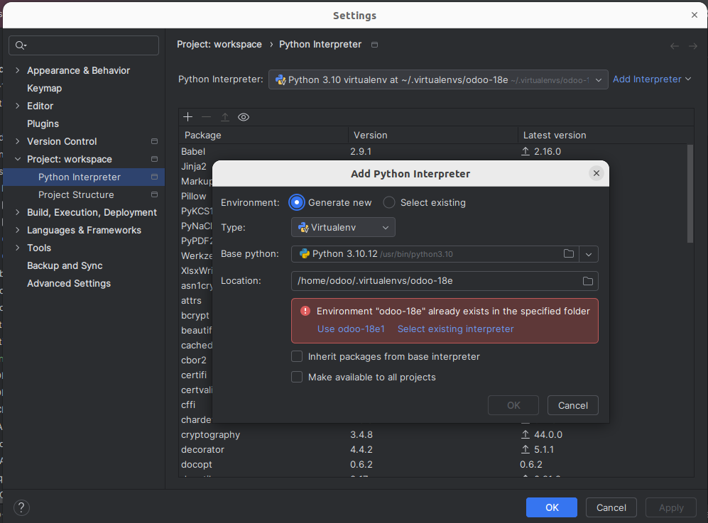

3.After add interpreter go to python configuration and Select Edit Configuration.

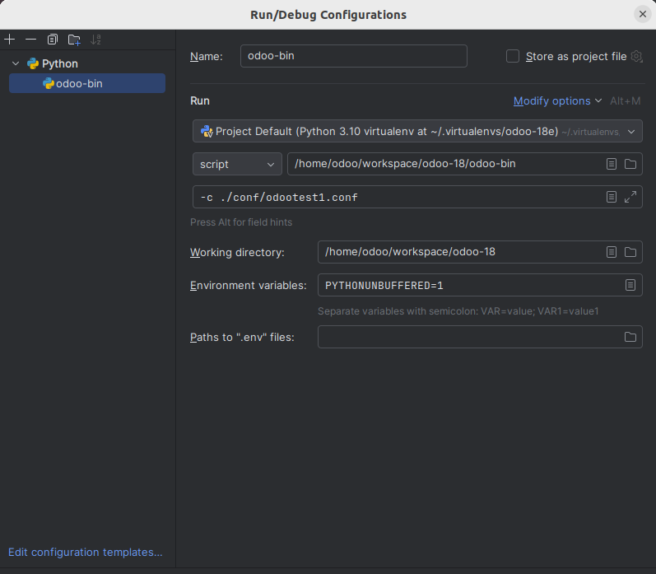

4.After click edit configuration select **/.virtualenvs/odoo-18e** interpreter path, and select odoo-bin path after add config file path **-c config_file_path** and click ok.

5.Also Add Working Directory Path.

6.Click the run button to start the odoo server….

